**AI-Powered Health Assistant**

A Project Report

submitted in partial fulfillment of the requirements

of

AICTE Internship on AI: Transformative Learning

with

TechSaksham – A joint CSR initiative of Microsoft & SAP

by

**Hanumantha B K, hhanumanthabk@gmail.com**

Under the Guidance of

**Aditya Prasant Ardak**

**Master Trainer, Edunet Foundation**

**ACKNOWLEDGEMENT**

We would like to take this opportunity to express our deep sense of gratitude to all individuals who helped us directly or indirectly during this thesis work.

Firstly, we would like to thank my supervisor, **Aditya Prasant Ardak**, for being a great mentor and the best adviser I could ever have. His advice, encouragement and the critics are a source of innovative ideas, inspiration and causes behind the successful completion of this project. The confidence shown in me by him was the biggest source of inspiration for me. It has been a privilege working with him for the last one year. He always helped me during my project and many other aspects related to the program. His talks and lessons not only help in project work and other activities of the program but also make me a good and responsible professional.

#### **ABSTRACT**

Access to timely and reliable healthcare remains a major challenge, especially in emergencies and remote areas. Patients often struggle to find nearby doctors, schedule appointments efficiently, and securely manage their medical records across different healthcare providers. "NearestDoctor" leverages AI and machine learning to analyze symptoms, recommend specialists, and facilitate real-time appointment booking. A chatbot provides instant medical assistance, while blockchain technology ensures secure, tamper-proof storage of patient records, accessible only with granted permissions. The system also integrates facial recognition for authentication and a paramedical e-shop for personalized health product recommendations. By addressing key inefficiencies in the healthcare system, "NearestDoctor" enhances accessibility, security, and efficiency in medical services.

**TABLE OF CONTENT**

**Abstract I**

**Chapter 1.**  **Introduction 1**

1.1 Problem Statement 1

1.2 Motivation 1

1.3 Objectives 2

1.4. Scope of the Project 2

**Chapter 2.**  **Literature Survey 3**

**Chapter 3.**  **Proposed Methodology**

**Chapter 4.**  **Implementation and Results**

**Chapter 5. Discussion and Conclusion**

**References**

**LIST OF FIGURES**

|  |  |  |
| --- | --- | --- |
| **Figure No.** | **Figure Caption** | **Page No.** |
|  | **Architecture** | **5** |
|  | **Implementation** | **7** |
|  | **Choose a role** | **8** |
|  | **FaceID Login** | **8** |
|  | **CardId verification** | **9** |
|  | **Success of cardID verification** | **9** |
|  | **List of blogs** | **10** |
|  | **Web scraping search** | **10** |

**CHAPTER 1**

**Introduction**

* 1. **Problem Statement:**

To design and develop an AI and blockchain Technology for the "NearestDoctor" to provide real-time doctor availability, symptom analysis, and secure medical record management.

* 1. **Motivation:**

The "NearestDoctor" project was chosen to address the growing challenges in healthcare accessibility, patient data security, and efficient medical service management. Many patients struggle to find nearby doctors, leading to delays in treatment, especially in emergencies. Additionally, traditional healthcare systems rely on centralized patient records, making them vulnerable to data breaches and loss. By integrating AI, machine learning, and blockchain, this project aims to provide a seamless, secure, and intelligent healthcare experience.

**Potential Applications & Impact**

* **Emergency Healthcare Assistance** – Patients can quickly find the nearest available doctor, reducing delays in critical situations.
* **AI-Powered Diagnosis** – Symptom analysis helps in early detection of illnesses and provides recommendations for specialist consultations.
* **Secure Medical Records** – Blockchain ensures privacy and integrity of patient records, accessible only by authorized doctors.
* **Smart Appointment Scheduling** – Real-time doctor availability improves efficiency in healthcare management.
* **Enhanced Authentication** – Facial recognition and ID verification prevent identity fraud in medical consultations.
* **E-Healthcare Expansion** – The paramedical e-shop uses machine learning to recommend health products tailored to individual needs.
  1. **Objective:**
* To design an AI-Powered Symptom Analysis for Utilize artificial intelligence to assess patient symptoms and recommend appropriate specialists.
* To develop Real-Time Doctor Availability & Appointment Scheduling thatEnable patients to find the nearest available doctor and book appointments efficiently.
* To provide an Secure Medical Record Management Implement blockchain technology to store and manage patient records securely, ensuring privacy and controlled access.
* To create Instant Medical Assistance via Chatbot that Provide AI-driven chatbot support for quick symptom queries and healthcare guidance.
* To provide an Advanced Authentication & Security Use facial recognition and ID verification to authenticate doctors and ensure secure access.
* To develop an Comprehensive Healthcare DashboardCentralize medical services, doctor schedules, and reports in a single interface for seamless management.
* To provide an Personalized Paramedical E-ShopLeverage machine learning to analyze patient behavior and recommend relevant health products.
  1. **Scope of the Project:**

The **"NearestDoctor"** project aims to enhance healthcare accessibility, efficiency, and security by leveraging AI, machine learning, and blockchain technology. The system enables patients to analyze symptoms, find the nearest available doctor, and schedule appointments in real time. AI-powered chatbots provide instant medical assistance, while blockchain ensures secure and decentralized storage of patient records, accessible only with granted permissions. The platform also integrates facial recognition for authentication and a paramedical e-shop that uses machine learning for personalized product recommendations. Designed as a web-based application, "NearestDoctor" supports scalability, real-time analytics, and cloud-based infrastructure for seamless access across multiple devices. By improving healthcare accessibility, optimizing medical resource allocation, and ensuring data security, this project has the potential to revolutionize patient care and medical service management.

**CHAPTER 2**

**Literature Survey**

* 1. **Review relevant literature or previous work in this domain.**

The integration of AI, machine learning, and blockchain in healthcare has been widely explored to enhance patient care, security, and efficiency. Previous studies have demonstrated the effectiveness of AI-powered symptom detection in diagnosing diseases with high accuracy, reducing the burden on healthcare professionals. Machine learning models have been implemented for patient satisfaction prediction and behavioral analysis, improving personalized healthcare experiences. Additionally, blockchain technology has been researched extensively for its ability to provide secure, decentralized, and tamper-proof storage of medical records, ensuring data privacy and controlled access. Various healthcare applications have adopted AI-driven chatbots for real-time medical assistance, streamlining patient interaction and appointment scheduling. However, many existing solutions lack seamless integration of these technologies into a unified system. "NearestDoctor" aims to bridge this gap by combining AI for symptom analysis, machine learning for patient insights, and blockchain for secure medical data management, offering an all-in-one healthcare solution that enhances accessibility, security, and efficiency.

* 1. **Mention any existing models, techniques, or methodologies related to the problem.**

Various models and techniques have been developed to enhance healthcare services, including AI-powered symptom detection, automated appointment scheduling, blockchain-based medical record management, and chatbot-assisted healthcare consultations. AI-based diagnostic tools, such as IBM Watson Health and Ada Health, utilize machine learning models like decision trees, deep learning, and natural language processing to analyze symptoms and recommend specialists. Platforms like Zocdoc and Practo offer appointment scheduling based on doctor availability, improving patient access to medical professionals. Blockchain solutions such as MedRec and Ethereum-based smart contracts provide decentralized and tamper-proof storage of patient records, ensuring data privacy and secure access control.

Additionally, AI-driven chatbots like Babylon Health and HealthTap assist patients by analyzing symptoms and offering medical guidance. Advanced authentication techniques, including facial recognition and ID verification, enhance security and prevent identity fraud in healthcare systems. While these models have individually improved different aspects of healthcare, "NearestDoctor" integrates these technologies into a single platform, combining AI for symptom analysis, blockchain for secure medical records, and automated scheduling to create a comprehensive, efficient, and secure healthcare solution.

* 1. **Highlight the gaps or limitations in existing solutions and how your project will address them.**

Despite advancements in AI-driven healthcare, existing solutions still face several limitations, including fragmented systems, lack of real-time doctor availability, data security risks, and inefficient patient record management. Many AI-based symptom detection tools provide recommendations but lack seamless integration with appointment scheduling systems, forcing patients to manually search for doctors. Additionally, traditional healthcare databases are centralized, making patient records vulnerable to cyberattacks, unauthorized access, and data breaches. While blockchain has been explored for secure medical records, its adoption remains limited due to complexity and lack of integration with other healthcare services.

"NearestDoctor" overcomes these challenges by offering an all-in-one platform that integrates AI-powered symptom analysis with real-time doctor availability and appointment scheduling. Unlike existing systems, it leverages blockchain to ensure medical records are securely stored and accessed only with patient consent, reducing privacy risks. The AI-driven chatbot provides instant responses, improving accessibility, while facial recognition and ID verification enhance security and prevent identity fraud. By addressing these limitations, "NearestDoctor" provides a comprehensive, secure, and efficient healthcare solution that bridges the gap between AI-driven diagnosis, doctor accessibility, and secure medical record management.

**CHAPTER 3**

**Proposed Methodology**

* 1. **System Design**

The **"NearestDoctor"** system is designed as a web-based AI healthcare assistant that integrates **AI, machine learning, and blockchain** to provide a seamless and secure healthcare experience. The architecture consists of several interconnected components, including **User Interface (UI), AI & Machine Learning Module, Blockchain Storage, Database, and Authentication System.**

At the **front-end**, users interact with a user-friendly web interface where they can input symptoms, find nearby doctors, schedule appointments, and access medical records. The **AI & Machine Learning Module** processes patient symptom data, predicts possible conditions, and recommends the appropriate specialist. A chatbot is integrated to provide real-time responses for patient queries. The **Appointment Scheduling System** connects patients with the nearest available doctor, optimizing time and accessibility.

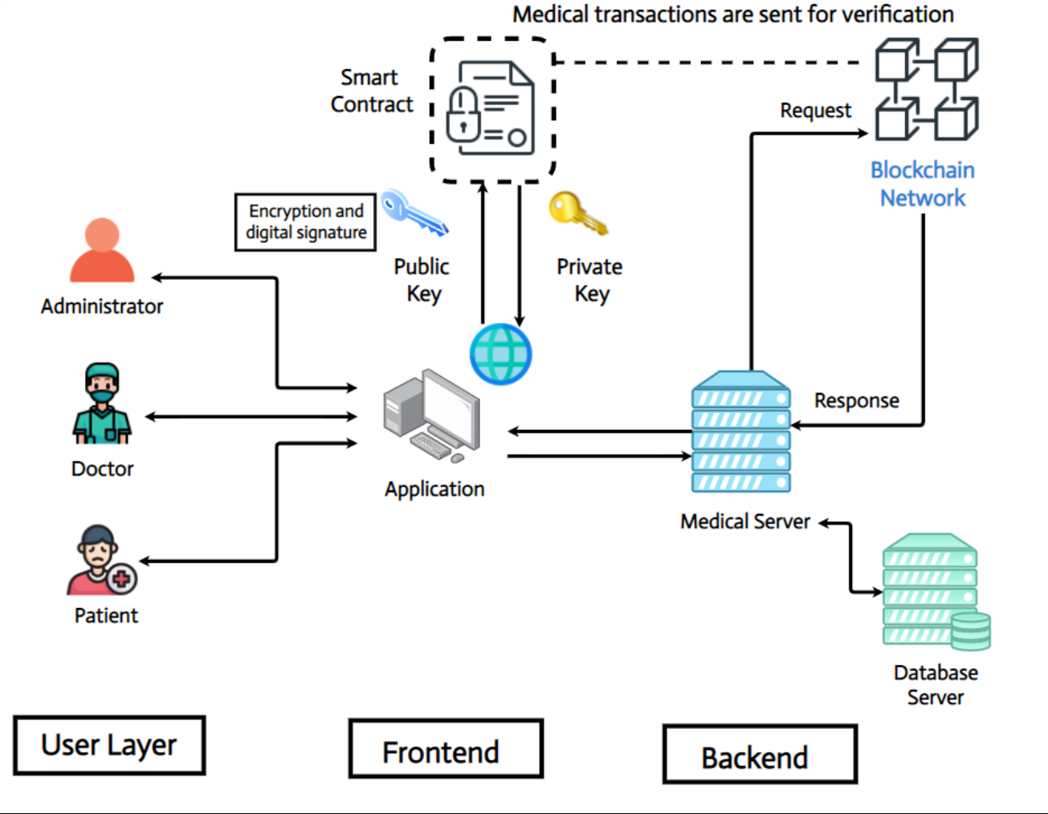

**Figure 1:** **Architecture**

The **Blockchain Storage** component securely stores medical records in a decentralized manner, ensuring tamper-proof data protection and controlled access through smart contracts. The **Database** maintains user profiles, doctor availability, and appointment details, ensuring seamless interactions between patients and healthcare providers. The **Authentication System** implements facial recognition and ID verification to enhance security and prevent unauthorized access to sensitive data.

By combining these components, **"NearestDoctor"** ensures real-time healthcare access, intelligent symptom analysis, secure medical record management, and fraud-resistant authentication, making it a **comprehensive and innovative healthcare solution.**

* 1. **Requirement Specification**

Mention the tools and technologies required to implement the solution.

* + 1. **Hardware Requirements:**
* Processor - Dual-core Intel or AMD processor, 2.0 GHz Or higher
* RAM - 256 MB (min)
* Hard Disk - 20 GB
* Floppy Drive - 1.44 MB
* Key Board - Standard Windows Keyboard
* Mouse - Two or Three Button Mouse
* Monitor - SVGA
  + 1. **Software Requirements:**
* **Python** (for AI/ML models and backend logic)
* **JavaScript (React.js, Node.js)** (for frontend and backend development)
* **Solidity** (for smart contracts on blockchain)
* **Flask / FastAPI / Django** (for backend API development)
* **React.js / Angular.js** (for web frontend)
* **TensorFlow / PyTorch** (for AI/ML symptom detection and predictions)
* **Web3.js / ethers.js** (for blockchain integration)

**CHAPTER 4**

**Implementation and Result**

The implementation of "NearestDoctor" follows a modular and structured approach, integrating AI, machine learning, blockchain, and web-based technologies to provide an efficient and secure healthcare system. The frontend is developed using React.js for the web interface and React Native for mobile compatibility, enabling patients to register, input symptoms, search for doctors, schedule appointments, and access medical records. The backend, built with Flask/FastAPI and Node.js, handles API requests, processes AI-based symptom detection using TensorFlow/PyTorch, and securely communicates with the frontend. The AI module analyzes patient symptoms to recommend specialists, predicts patient satisfaction in the forum, and utilizes machine learning for personalized healthcare recommendations in the paramedical e-shop.

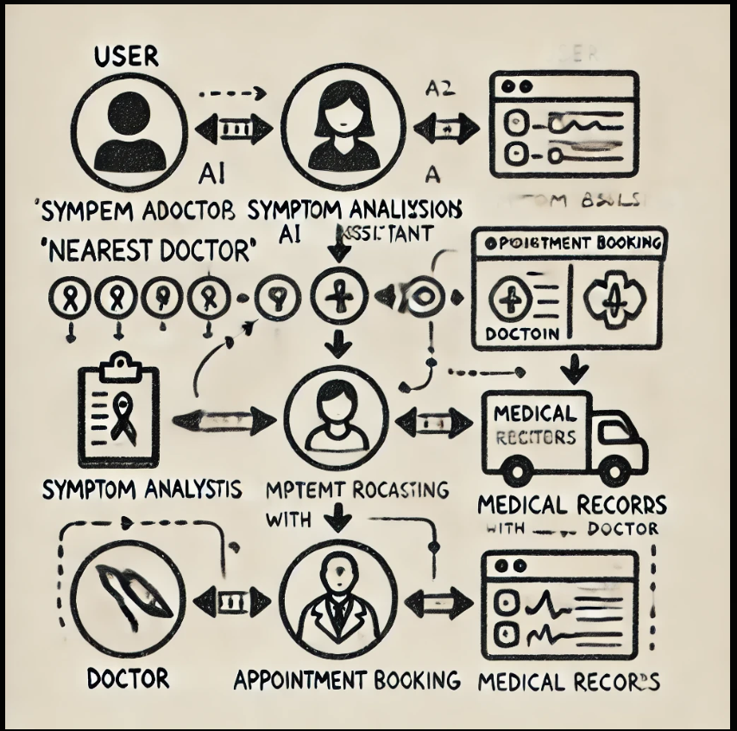To ensure secure medical data management, blockchain technology using Solidity and Ethereum is implemented for decentralized medical record storage, allowing only authorized doctors access through smart contracts. Security measures include facial recognition via OpenCV and ID verification, while encryption techniques such as AES and SHA-256 protect sensitive patient data. The system is deployed on AWS/Firebase for cloud hosting, with Docker and Kubernetes ensuring scalability. Comprehensive testing is conducted using Postman for API validation, Selenium for UI testing, and JUnit for backend functionality. By integrating these advanced technologies, "NearestDoctor" provides a seamless, intelligent, and secure healthcare solution that enhances accessibility and efficiency in medical services.

**Figure 2 : Implementation**

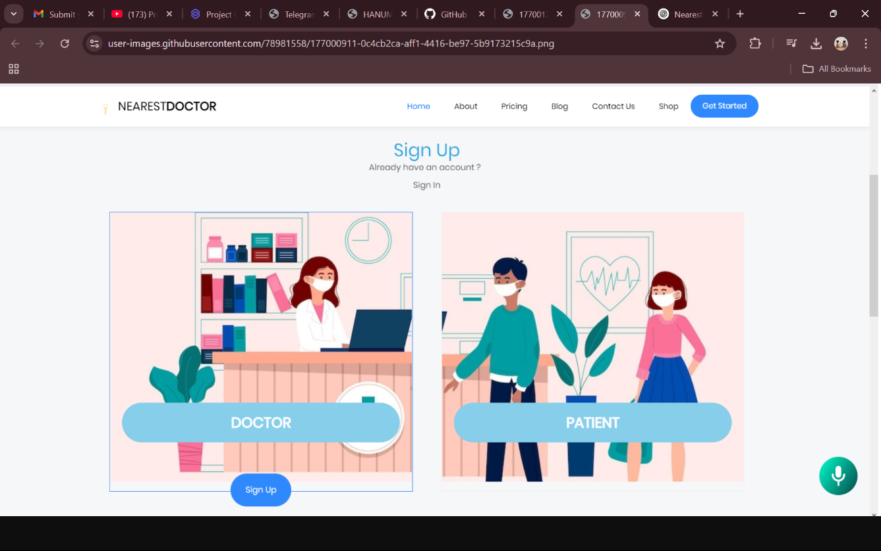**4.1 Snap Shots of Result:**

**Figure 3 : Choose a role**

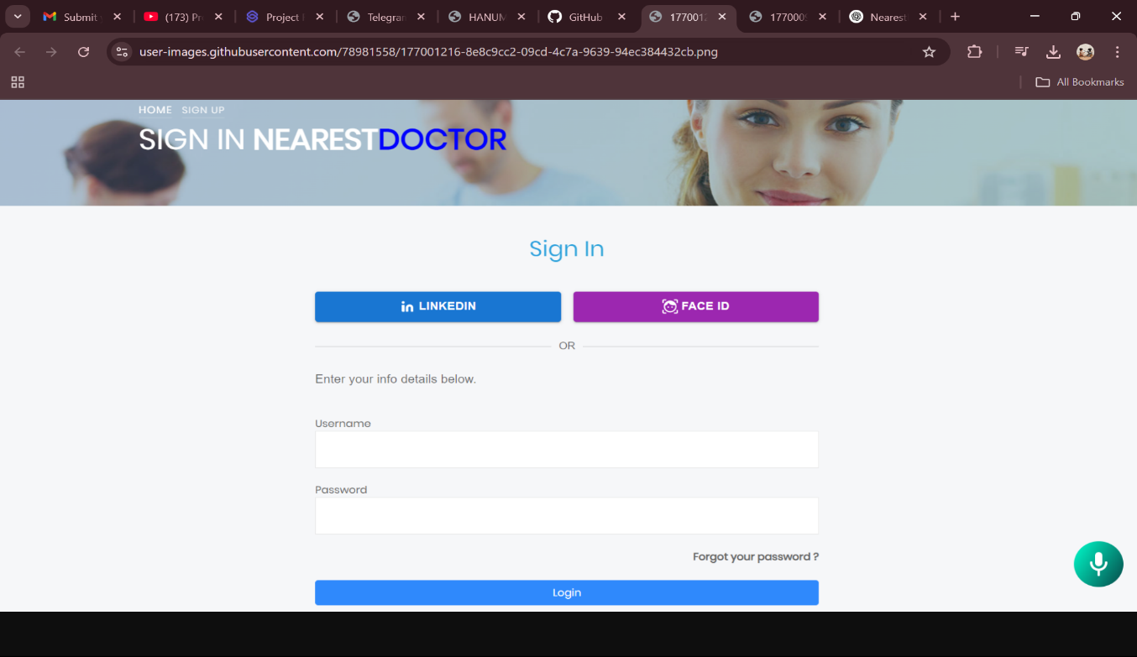

**Figure 4 : FaceID Login**

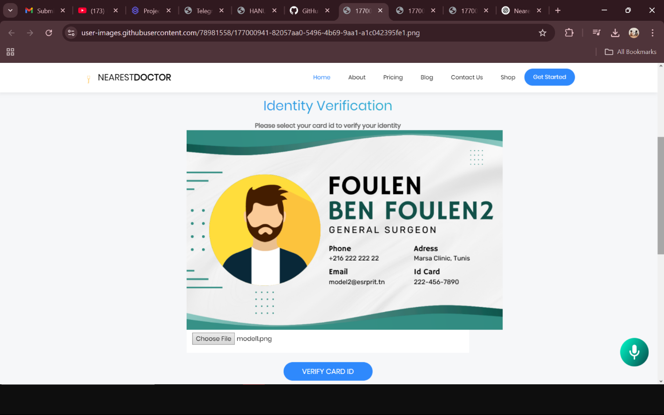 **Figure 5 : CardId verification**

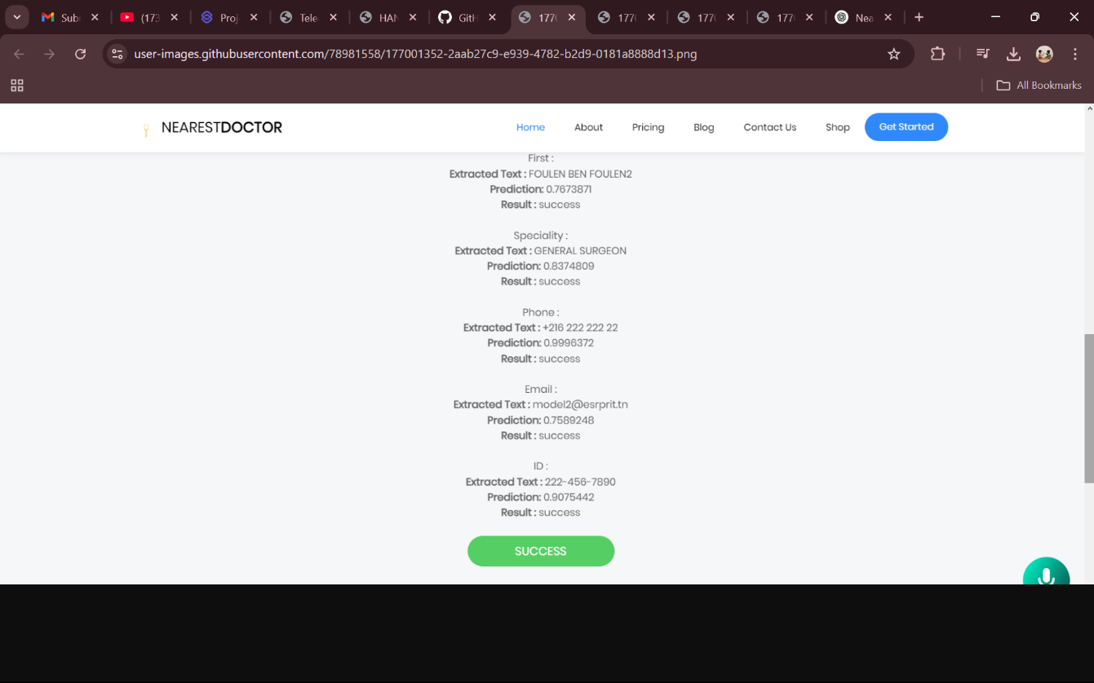

**Figure 6 : Success of cardID verification**

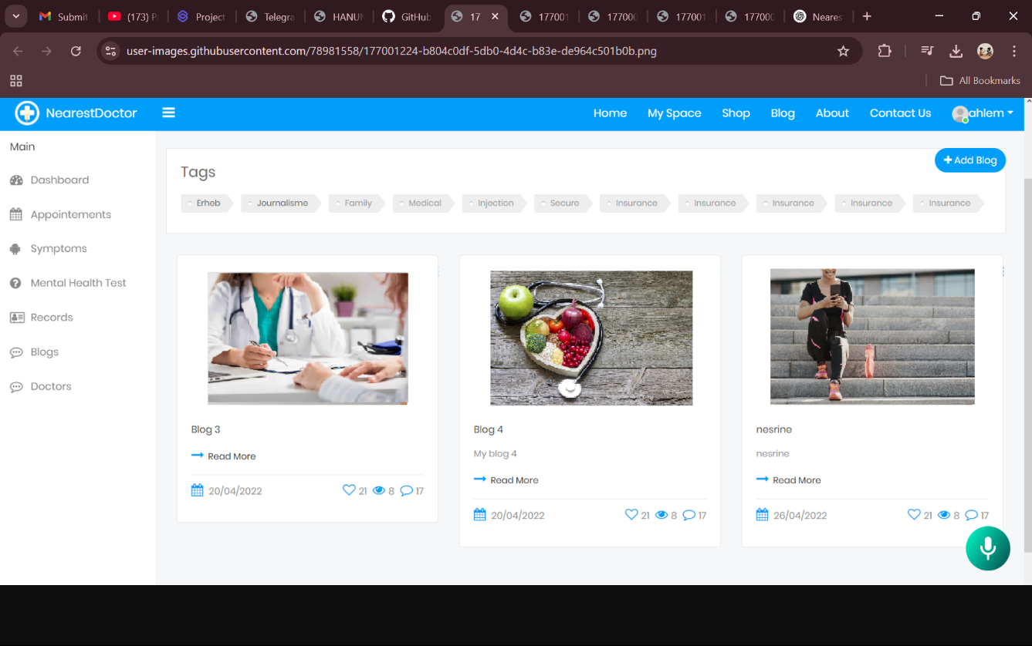 **Figure 7 : List of blogs**

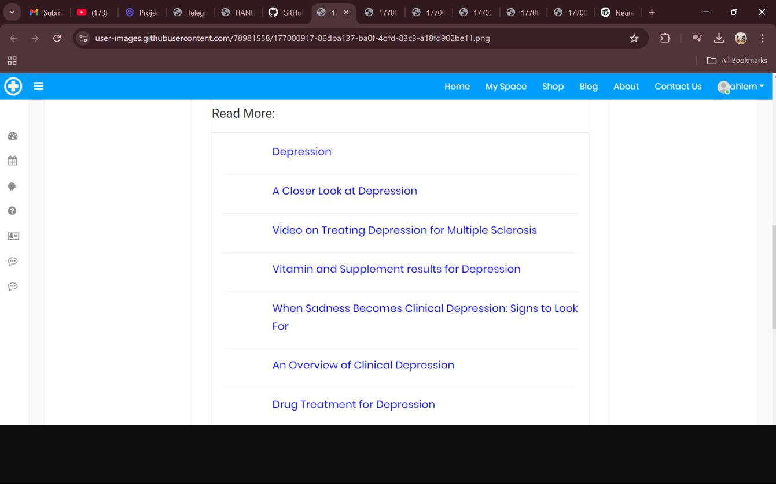

**Figure 8 : Web scraping search**

* 1. **GitHub Link for Code:**

**https://github.com/Hanumantha-bk/AI-Powered-Health-Assistant**

**CHAPTER 5**

**Discussion and Conclusion**

* 1. **Future Work:**

The "NearestDoctor" system has immense potential for future enhancements to further improve healthcare accessibility, security, and efficiency. One key area of development is AI-driven predictive healthcare, where machine learning models can analyze patient history to anticipate potential health risks and recommend preventive measures. Enhancing natural language processing (NLP) in chatbots will enable more context-aware and intelligent medical assistance, making patient interactions more accurate and personalized. Additionally, integrating IoT-based wearable devices such as smartwatches and health monitors can provide real-time health tracking, allowing doctors to make better-informed decisions.

Expanding **blockchain interoperability** will facilitate secure medical data exchange between hospitals and healthcare institutions worldwide, ensuring seamless patient care coordination. Another crucial advancement would be **telemedicine and video consultations**, enabling remote doctor-patient interactions and reducing the need for in-person visits, especially in rural or underserved areas. Furthermore, incorporating **advanced biometric authentication** methods like voice recognition and fingerprint scanning will strengthen security and prevent unauthorized access to medical records. To enhance inclusivity, **multi-language accessibility** can be implemented, making the platform more user-friendly for diverse populations. By continuously integrating these cutting-edge technologies, **"NearestDoctor"** aims to revolutionize digital healthcare and provide a seamless, intelligent, and secure medical assistance platform.

* 1. **Conclusion:**

The "NearestDoctor" system is an innovative AI-driven healthcare assistant that enhances patient accessibility, security, and efficiency through the integration of AI, machine learning, and blockchain technology. By enabling real-time symptom analysis, doctor availability tracking, secure medical record management, and AI-powered chat support, the platform significantly improves the patient experience. Blockchain ensures tamper-proof and decentralized medical records, while facial recognition and advanced authentication mechanisms provide enhanced security. The system also incorporates machine learning for patient behavior prediction, appointment optimization, and paramedical recommendations. With future advancements such as IoT integration, telemedicine, and enhanced AI-driven diagnostics, "NearestDoctor" has the potential to revolutionize digital healthcare, offering a secure, intelligent, and seamless solution that improves medical service accessibility and efficiency on a global scale.

**REFERENCES**

1. A. Allen, ‘‘Morphing telemedicine-telecare-telehealth-ehealth,’’ Telemed Today, Special, no. 2000, 2000.
2. S. L. Murphy, J. Xu, K. D. Kochanek, and E. Arias, ‘‘Mortality in the United States, 2017,’’ NCHS Data Brief, no. 328, pp. 1–8, Nov. 2018.
3. K. Myers, P. Berry, J. Blythe, K. Conley, M. Gervasio, D. L. McGuinness, D. Morley, A. Pfeffer, M. Pollack, and M. Tambe, ‘‘An intelligent personal assistant for task and time management,’’ AI Mag., vol. 28, no. 2, p. 47, 2007.
4. R. Sarikaya, ‘‘The technology powering personal digital assistants,’’ in Proc. 16th Annu. Conf. Int. Speech Commun. Assoc. (INTERSPEECH), Dresden, Germany. Kolkata, India: ISCA, Sep. 2015, pp. 2022–2026. [Online]. Available: <http://www.iscaspeech.org/archive/interspeech_2015/i15_4002.html>.
5. A. S. Tulshan and S. N. Dhage, ‘‘Survey on virtual assistant: Google assistant, Siri, Cortana, Alexa,’’ in Proc. Int. Symp. Signal Process. Intell. Recognit. Syst. Cham, Switzerland: Springer, 2018, pp. 190–201.
6. S. Devi, Z. A. M. Merchant, M. S. Siddiqui, and M. Lobo, ‘‘Artificial intelligence based personal assistant,’’ Asian J. Converg. Technol., vol. 5, no. 1, pp. 1–4, 2019.
7. ] R. W. White, ‘‘Skill discovery in virtual assistants,’’ Commun. ACM, vol. 61, no. 11, pp. 106–113, Oct. 2018.
8. J. E. W. C. Van Gemert-Pijnen, O. Peters, and H. C. Ossebaard, Improving EHealth. The Hague, The Netherlands: Eleven International Publishing, 2013.
9. T. Morita, A. Rahman, T. Hasegawa, A. Ozaki, and T. Tanimoto, ‘‘The potential possibility of symptom checker,’’ Int. J. Health Policy Manage., vol. 6, no. 10, p. 615, 2017.
10. D. Braun, A. Hernandez-Mendez, F. Matthes, and M. Langen, ‘‘Evaluating natural language understanding services for conversational question answering systems,’’ in Proc. 18th Annu. SIGdial Meeting Discourse Dialogue, 2017, pp. 174–185.
11. T. M. Mitchell, Machine Learning. New York, NY, USA: McGraw-Hill, Mar. 1997.
12. D. R. Cox, ‘‘The regression analysis of binary sequences,’’ J. Roy. Stat. Soc., B (Methodol.), vol. 20, no. 2, pp. 215–232, Jul. 1958.
13. L. Breiman, ‘‘Random forests,’’ Mach. Learn., vol. 45, no. 1, pp. 5–32, 2001.
14. R. W. White, ‘‘Skill discovery in virtual assistants,’’ Commun. ACM, vol. 61, no. 11, pp. 106–113, Oct. 2018.
15. ] D. W. Ruck, S. K. Rogers, M. Kabrisky, M. E. Oxley, and B. W. Suter, ‘‘The multilayer perceptron as an approximation to a Bayes optimal discriminant function,’’ IEEE Trans. Neural Netw., vol. 1, no. 4, pp. 296–298, Dec. 1990.